This visualisation is to reveal the different level of development in different regions, different countries and even in different genders. The idea comes from the Human Development Report (HDR), which is published by the United Nations development programme. In this report, this organisation calculated some indexes to show some aspects of the truth. For example, Human Development Index (HDI), Poverty Index (PI) and Gender Development Index (GDI), which are supported by many data published by many organisations. However, the data behind the calculated indexes is not revealed. To calculated HDI, they choose following variables: *Life expectancy at birth*, *Expected years of schooling*, *Mean years of schooling*, *Gross national income (GNI) per capita* as the main components. UN has its reason to select these variables to calculate the index called HDI, but besides that, some important data behind indexes should also be revealed to give the user of the interactive project a whole picture.

To fulfil our destination to reveal the inequality of income, gender, and education. These are the graphs (functions) we want to add into shiny:

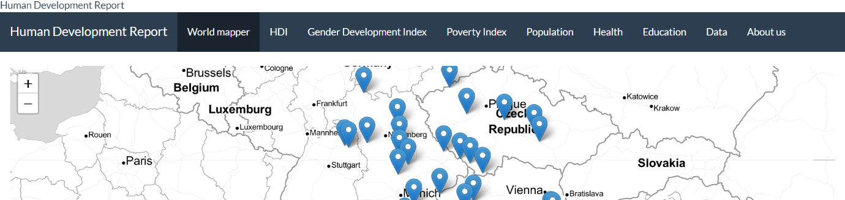

|  |  |  |
| --- | --- | --- |
| **World Mapper** | Users are able to choose an index to be present in the heatmap map (animation: year) |  |
| **All** | Trend of index for selected countries |  |
| Bubble plot |  |
| Circular plot |  |
| Radar Plot |  |
| **HDI** | Calculation |  |
| A chart to show the difference between HDI in 1900 and HDI in 2018 |  |
| **GII** | Population-Aged Pyramid? |  |
| Male/female ratio + pie chart map? |  |
| Difference between education? |  |
| Difference between occupation? |  |
| **PI** |  |  |
| Poverty by different countries, a simple distribution. |  |
| Income distribution |  |
| **Education** | Sankey diagram  （I am considering whether we can use Sankey diagram to compare the proportion of different education level of different continent. (This code is just a sample.) |  |
| Bullet Graph | To show the expected schooling year and the actual schooling year. |
| **Population** |  |  |